**how to list all users in Linux through CLI?**

To list all users in Linux through the command-line interface (CLI), you can use the cut, sort, and uniq commands in combination with the /etc/passwd file, which contains information about all users on the system.

Here's how to do it:

Open a terminal window.

Type the following command and press Enter:

**cut -d: -f1 /etc/passwd | sort | uniq**

This command uses the **cut** command to extract the first field (the username) from the **/etc/passwd** file, which is separated by colons. The **sort** command sorts the list of usernames in alphabetical order, and the **uniq** command removes any duplicates.

After running this command, you should see a list of all the usernames on your Linux system.

Note: Depending on your system configuration, there may be additional users that do not have entries in the **/etc/passwd** file, or there may be other files that contain user information that you need to consult.

**-**

**Linux Admin**

* + **Who is an Admin in Linux?**
  + **Root is not an Admin 🡪 root is a super user.**
  + **In Linux the user that have UID 0 is an Admin.**
  + **Root is just a name**
  + 
  + **Kernel always look for UID and 0 UID means super user**

**-**

**FIX yum command not working.**

* **curl https://www.getpagespeed.com/files/centos6-eol.repo --output /etc/yum.repos.d/CentOS-Base.repo**

**-**

**$ ls -d command,**

The ls -d command in Linux is used to list only the directories specified in the command-line arguments or the current directory if no arguments are provided.

The -d option stands for "directory" and tells the ls command to list the directories themselves, rather than their contents. When used without any arguments, it lists the current directory.

For example, if you run the command ls -d /home/user/Documents, it will display the name of the directory /home/user/Documents if it exists. If you run the command ls -d, it will display the name of the current directory.

The ls -d command can be useful for checking the existence of directories, or for quickly listing a few specific directories without having to look through their contents.

**-================================================================================**

**$ ls -Za**

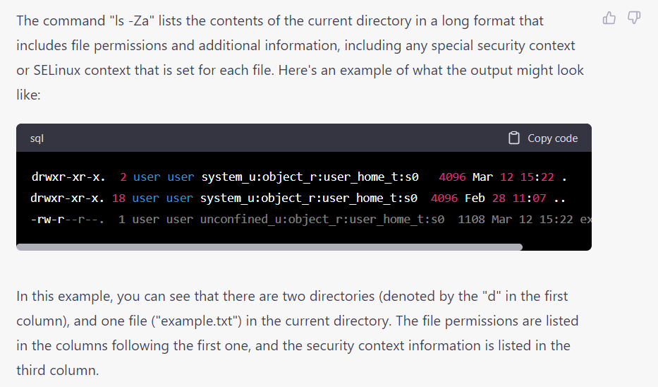

**.===============================================================================**

**$ ip -br a**

"ip -br a" is a command used in Linux and Unix-like operating systems to display the network interface configuration in a brief and easily readable format.

===========================================================

**how to create a user and a group with a single command?**

In Linux, you can create a user and a group at the same time using the **adduser** command with the **--group** option. Here's an example of how to create a new user called "john" and a new group called "dbs_users" using a single command:

**sudo adduser --ingroup dbs_users john**

This command will create a new user called "john" and a new group called "dbs_users" on the system. The **--ingroup** option tells **adduser** to add the new user to the specified group.

You can replace "dbs_users" with the name of the group you want to create. If the group already exists, the **adduser** command will add the new user to the existing group.

Note that the **adduser** command requires root or sudo privileges.

**what is the difference b/w adduser and useradd?**

In Linux, **adduser** and **useradd** are two commands that are used to create new users. Although they may seem similar, there are some differences between them:

1. Usage: The **useradd** command is a low-level command that is primarily used to create new user accounts. It requires the user to specify all the parameters for the new user account. The **adduser** command is a high-level command that provides an interactive interface for creating new user accounts. It prompts the user for information and sets default values for some of the parameters.
2. Default behavior: The **useradd** command creates a new user account with a default configuration, whereas the **adduser** command creates a new user account with a more secure and usable configuration. For example, **adduser** sets a home directory for the new user and creates a group with the same name as the user.
3. User interaction: The **adduser** command provides an interactive interface that prompts the user for information, such as the user's full name and password. The **useradd** command does not provide an interactive interface and requires the user to specify all the parameters on the command line.
4. Compatibility: The **adduser** command is a more modern command that is available on most modern Linux distributions, while **useradd** is a more traditional command that is still used on some older distributions. The **adduser** command is generally more user-friendly and has become the preferred command for creating new user accounts.

In summary, the **adduser** command is a high-level command that provides an interactive interface for creating new user accounts with secure and usable configurations, while the **useradd** command is a low-level command that is primarily used to create new user accounts with default configurations.

what parameters are required to be specified for "useradd" command for a new user?

When using the **useradd** command to create a new user in Linux, the minimum set of parameters required are:

1. Username: The username of the new user must be specified as the first argument to the **useradd** command. For example:

**sudo useradd john**

1. Password: You can set a password for the new user by using the **passwd** command. For example:

**sudo passwd john**

1. Home directory: You can specify a home directory for the new user using the **-d** option. For example:

**sudo useradd -d /home/john john**

1. User ID: You can specify a numeric user ID for the new user using the **-u** option. For example:

**sudo useradd -u 1001 john**

Note that when you create a new user using the **useradd** command, a corresponding group with the same name as the user is also created. The new user is added to this group by default.

These are the minimum set of parameters required to create a new user with the **useradd** command. There are many other options available to customize the user account, such as specifying a login shell, setting the expiration date, and more. You can refer to the **useradd** manual page (**man useradd**) for more information.